

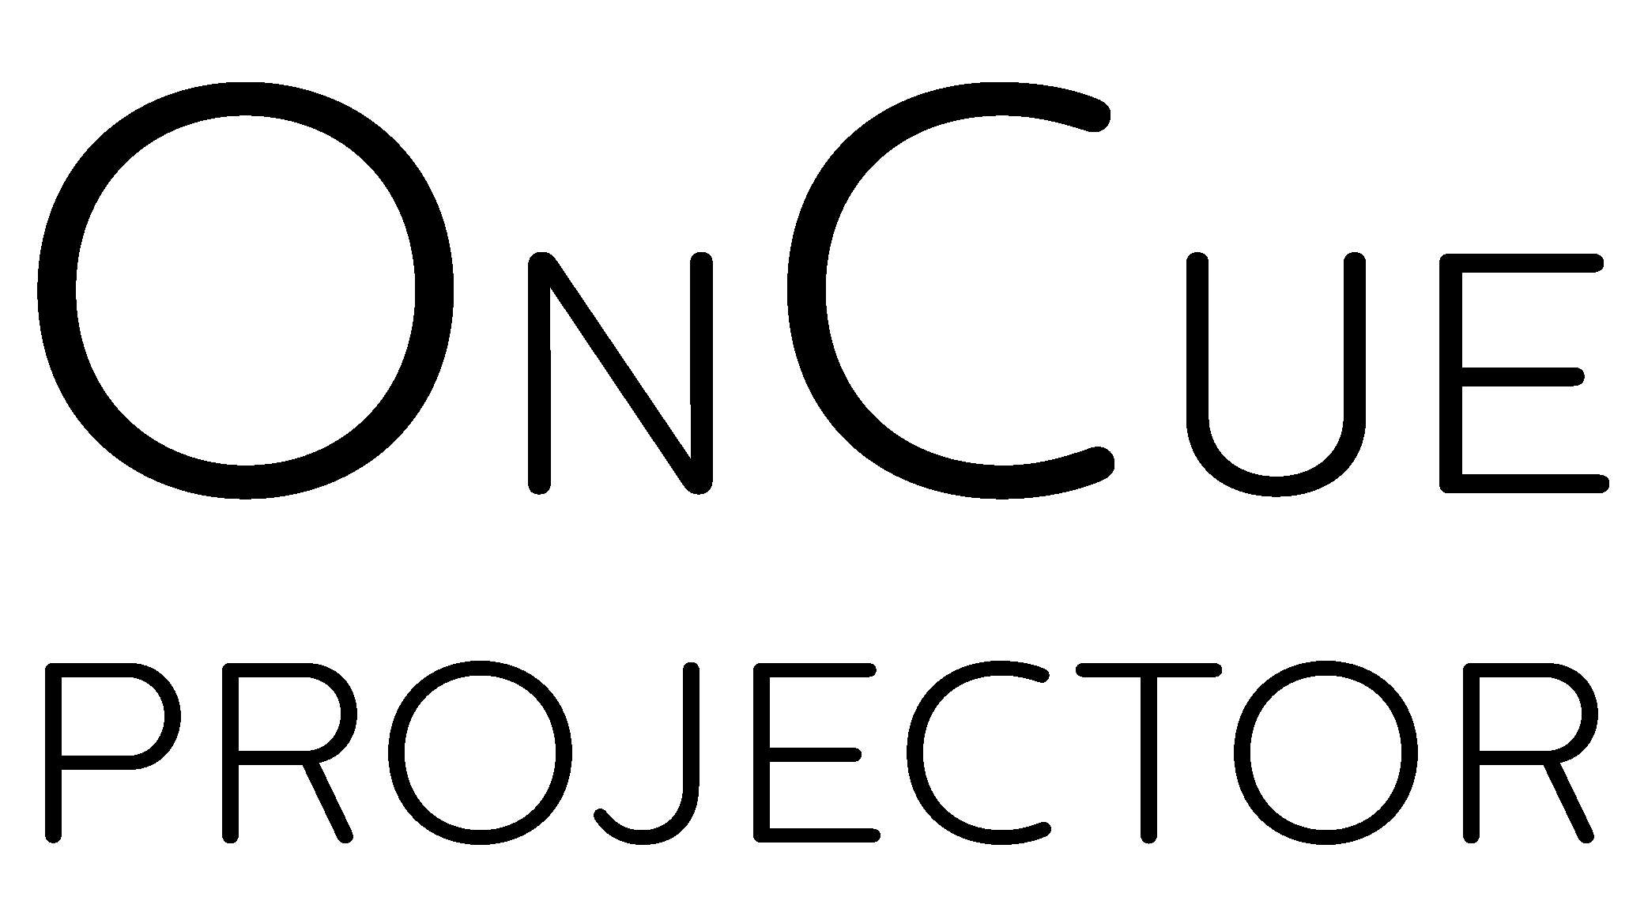

Technical Manual

*Content updated 5/07/2017*

# Original Storyboard and Screen Design

# Current Storyboard and Screen Design

# Gantt Chart

# 

# Data Dictionary: User Scope (Python)

|  |  |  |  |
| --- | --- | --- | --- |
| Field Name | Data Type | Example | Description |
| display | dict | - | Display settings |
| display.backgroundaudio | int | 0 or 1 | Audio behaviour when backgrounded 0: Mute when hidden 1: Play when hidden |
| display.backgroundmedia | int | 0 or 1 | Media behaviour when backgrounded 0: Pause when hidden 1: Play when hidden |
| display.outputbackground | str | “FFFFFF” | Hex code of the output background |
| display.outputID | int | integer | Monitor for output display |
| display.stagebackground | str | “FFFFFF” | Hex code of the stage background |
| display.stageID | int | integer | Monitor for stage display |
| interface | dict | - | Interface settings |
| interface.theme | tuple([str,str,str]) | (“FFFFFF”, “FFFFFF”, “FFFFFF”) | Contains the current application colour scheme |

# Code Inspection

### OnCue Development Launcher

Description: Compiles Qt interface into Python, and launches OnCue

**:: helper/OnCue (Compile and Run).bat ::**  


### Utility Functions

Description: Provides utility functions to the program (Function explanation in full source code)

**:: snippet of oncue/lib/utils.py ::**  


### Getting Computer Monitor Information

Description: Queries the Windows API for monitor information, and parses it

**:: snippet of OnCue.py ::**



### Qt Colour Picker Override

Description: Utilises Qt’s QColorDialog class as a basis for OnCue’s colour picker

**:: snippet of oncue/forms/colorPicker.py ::**

# Developer Questions

## How does OnCue Projector actually work?

OnCue is written in [Python](https://www.python.org/) (3.6), using the [Qt](https://www.qt.io/) framework through the [PyQt](https://riverbankcomputing.com/software/pyqt/) bindings.

Audio and video files are handled with the [libVLC](http://www.videolan.org/vlc/libvlc.html) (VLC SDK) media framework

PowerPoint presentations are handled by Microsoft’s [PowerPoint COM](https://msdn.microsoft.com/en-us/vba/powerpoint-vba/articles/object-model-powerpoint-vba-reference) object

## Open Source?

Yes! Check out the source code at <github.com/bearbear12345/OnCue>

## OS X / Linux Version?

Not yet – OnCue Projector uses Windows specific libraries and functions that are not available on other operating system platforms. However, redesign of OnCue for cross-compatibility may happen.

# Attribution

OnCue Projector is licensed under the GNU General Public License v3.0.  
You are free to redistribute it and/or modify it under the terms of the license.  
*For more details see the*[LICENSE](https://raw.githubusercontent.com/bearbear12345/OnCue/master/LICENSE)*file*

This application contains third-party libraries and code. Copyright is given where due.